# Title: On various theater's pages. Contact-center's phone is not mentioned and the “phone” text/image are not clickable.

**Priority:** Medium

**Severity:** S4 Minor

**Environment:** Browser Mozilla Firefox 118.0.1 (64-bit)

**Steps to reproduce**

1. Go to the Main page <https://multiplex.ua/>

2. Click on “burger-menu” at the left upper-corner of the page.

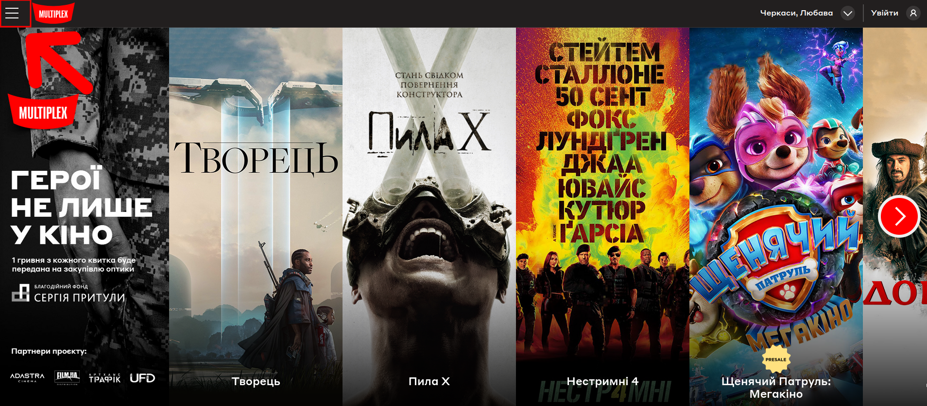

3. In the left-slide menu, click “Кінотеатри”.

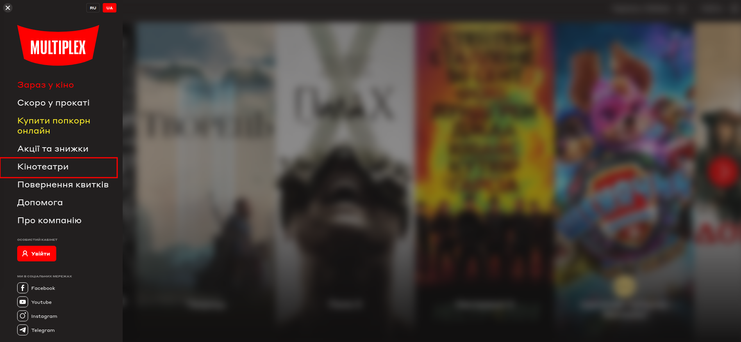

4. On the new page (with a list of theaters) click on the title of the first theater in the list: “Lavina IMAX Лазер”.

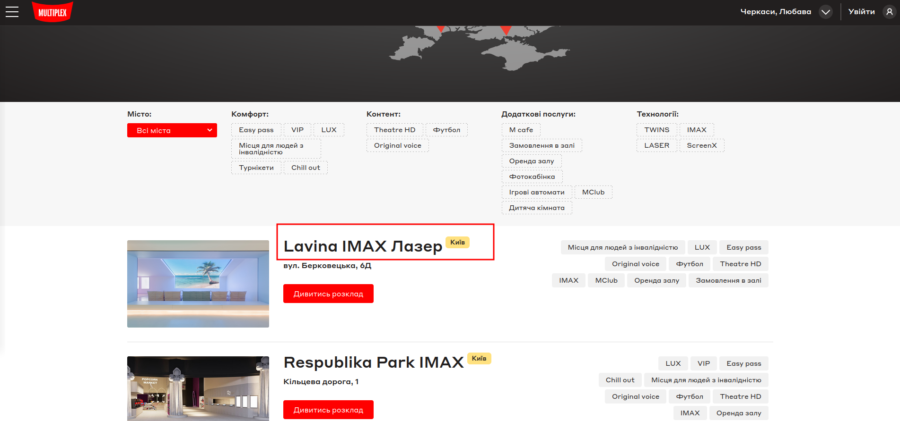

5. On the Lavina’s theater page, click by a mouse on “Контакт-центр” phrase in a right corner of the main banner.

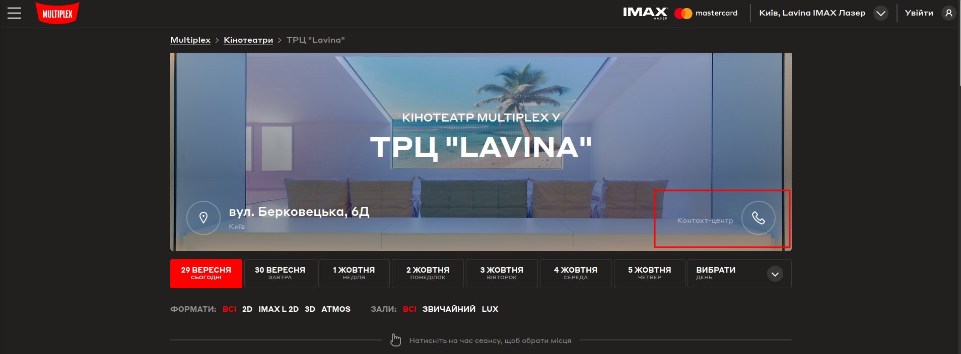

**Actual result**

The “Контакт-центр” phrase and the “phone” icon are not clickable. The phone number is not even mentioned on a banner.

**Expected result**

The “Контакт-центр” phrase and the “phone” icon must be clickable. The phone number is mentioned on a banner. A good example is represented on this page: <https://multiplex.ua/cinema/cherkasy/lyubava>

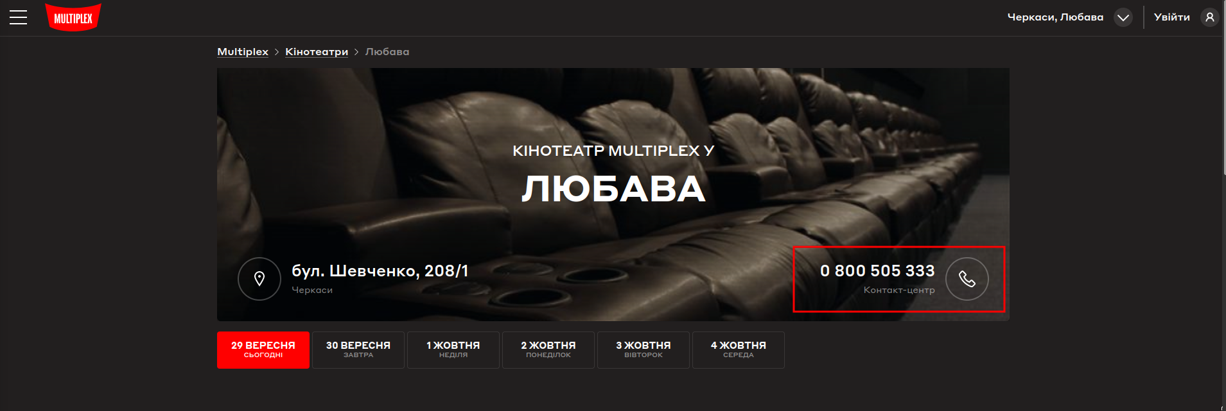

*Screenshot from* ***Jira****:*

